* **Activity 4:**

### Group Functions and Null Values

**Calculate the average ticket price, considering null values.**

1. **First Query (without handling null values):**

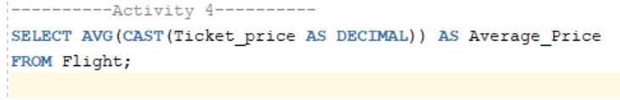

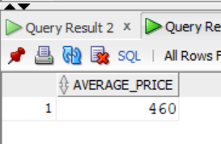Output:

1. **Second Query (handling null values):**

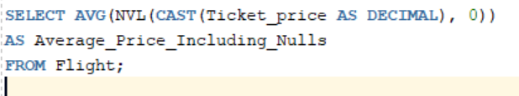

Output:

